Practical No: 07
Aim:List and Combo Box Item Verification Tool: Selenium WebDriver Automate the process of identifying a list or dropdown box on a web page and determine the total number of items. Validate default selected value and perform selection testing.
PRE-REQUISITES:
1) Check that you have JDK.
2) Check that you have Eclipse IDE.
3) Check that you have Selenium Server Driver and Client Driver(JAR files). 4) Check that you have Gecko Driver.
5) Check that you have a stable Internet connection.
STEPS:
1) Open Eclipse. Select your workspace directory. Click Launch:
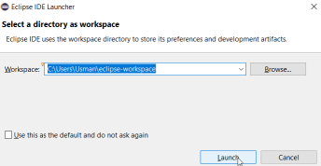2) Create a Project(File > New > Java Project):
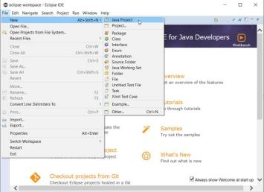
3) Name the project as “p9” > click Finish > click Don’t Create module:
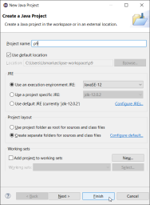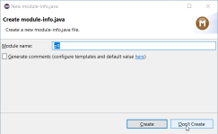4) Close the “Welcome” tab.
5) Create a Package(right-click on Project Name > New > Package > Name it > Finish): 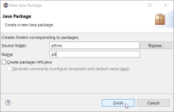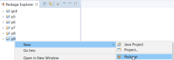6) Create a Class(right-click on Project Name > New > Class > Name it > Finish): 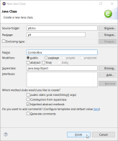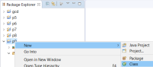7) Adding “Selenium Server Driver and Client Driver(JAR files)” in Eclipse IDE:
• right-click on Project Name > Build Path > Configure Build Path…
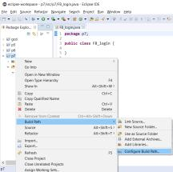
• now go under: Java Build Path > Libraries > Classpath > click Add External JARs… 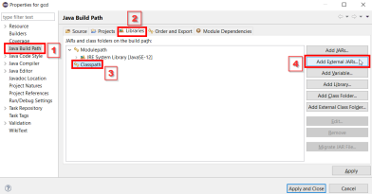
• Browse and add JAR files > click Apply and Close :
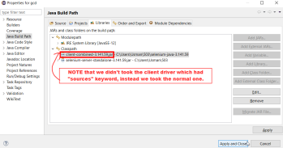8) Create HTML file in a notepad > Save it > Open it in browser > Copy the URL: (NOTE
THAT: as this is our LOCAL FILE, this file will be opened thru STATIC URL in script) ---(combobox.html)---
<select id="continents">
<option value="Asia">Asia</option>
<option value="Europe">Europe</option>
<option value="Africa">Africa</option>
</select>
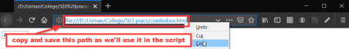9) Creating the script in JAVA:
(NOTE that this script will be run by Eclipse IDE)
(In simple words, it’s like we are
-ordering Eclipse to run a script or to do a job
-of opening the browser, visiting the URL
-and finding the WebElement By “ID” with the help of “Select” class and Selenium Drivers -and to show the result.
-Hence automating the work in browser)
• Now we’ll put the path of our LOCAL FILE(combobox.html) in a string
• Also put the path of “geckodriver” in a String driverPath
---(ComboBox.java)---
package p9;
import java.util.List;
import org.openqa.selenium.By;
import org.openqa.selenium.WebDriver;
import org.openqa.selenium.WebElement;
import org.openqa.selenium.firefox.FirefoxDriver;
import org.openqa.selenium.firefox.*;
import org.openqa.selenium.firefox.FirefoxOptions;
import org.openqa.selenium.firefox.FirefoxProfile;
import org.openqa.selenium.firefox.internal.ProfilesIni;
import org.openqa.selenium.support.ui.Select;
public class ComboBox {
static String driverPath = "C:\\Users\\Usman\\503\\geckodriver.exe"; public static void main(String[] args) {
System.setProperty("webdriver.gecko.driver",driverPath);
//NOTE THAT: following commented lines are required for old machines //DesiredCapabilities capabilities = DesiredCapabilities.firefox(); //capabilities.setCapability("marionette",true);
//ProfilesIni allProfiles = new ProfilesIni();
//FirefoxProfile fp = new FirefoxProfile();
//fp.setPreference(FirefoxProfile.PORT_PREFERENCE,"7055");
//FirefoxOptions options = new FirefoxOptions();
//options.setProfile(fp);
WebDriver driver = new FirefoxDriver();
String appUrl ="https://www.toolsqa.com/automation-practice-form/"; //DYNAMIC URL(WEBSITE)
//String appUrl = "
file:///D:/Usman/College/503%20pracs/combobox.html"; //STATIC URL(LOCAL FILE) driver.get(appUrl);
Select oSelect = new
Select(driver.findElement(By.id("continents")));
//Select oSelect = new
Select(driver.findElement(By.tagName("select"))); //this works too
List<WebElement> oSize = oSelect.getOptions();
int iListSize = oSize.size();
for(int i =0; i < iListSize ; i++)
{
// Storing the value of the option
String sValue = oSelect.getOptions().get(i).getText();
// Printing the stored value
System.out.println(sValue);
}
System.out.println("Total No. Items in Dropdown: "+iListSize);
//driver.quit();
}
}
10) Run the file from Eclipse IDE:
• OUTPUT:
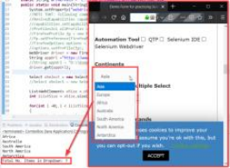
Figure 1: by using the DYNAMIC URL(website)
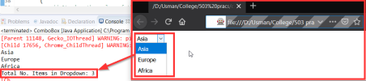Figure 2: by using the STATIC URL(local file)

